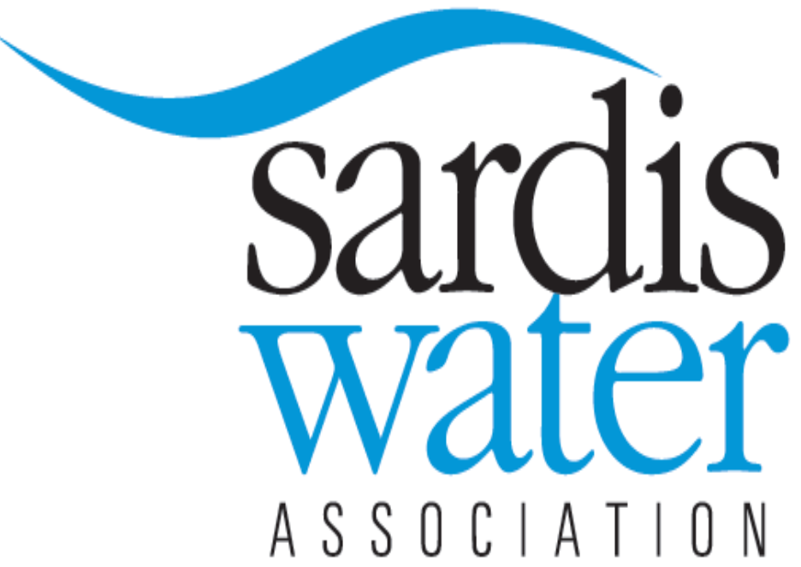
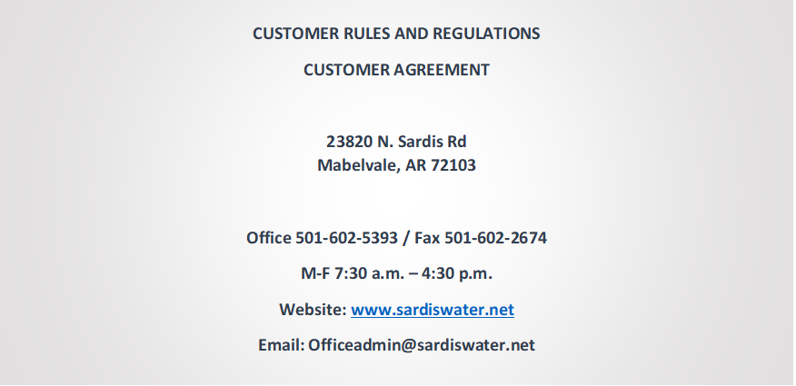
SERVICE FEES
All customers/members must complete a Customer Agreement when applying for service from SWA whether it’s brand new service (service has never been on the property to be serviced) or to have a meter set where service already exists. A copy of driver’s license is required; phone numbers and email are also requested if available. All new service connection fees (Connection, Capital Improvement, Deposits, Service Charges, and Plumbing Inspections) must be paid prior to constructing a new service. The customer’s /member’s complete mailing address (present and/or permanent) legal description and approved sewage disposal permit for the property to be served must be given to the SWA office when applying for new service prior to acceptance of any new service connection fees.
Original “Customer Agreement” must be paid in full prior to constructing a new service connection.
Service may be denied to a potential customer if they have a delinquent account at the time they apply for new service. Service will be available when the delinquent account and any penalties thereto have been paid.

DEPOSIT - $100.00 (For larger service meters contact the SWA Office)
Required prior to construction of a new service connection or restoration of a meter to an existing service connection. Each residence is required to have a deposit. We do not transfer deposits. A deposit may be refunded only when the final bill has been paid in full or the final is less than the deposit, then the balance will be refunded.

SERVICE CHARGE - $25.00
Required by all new or existing customers or members for each trip made to set or pull a meter. Service charges after hours of SWA are $50.00.

CAPITAL IMPROVEMENT/STORAGE TANK IMPACT FEE - $325.00
Required for new or existing customer or member for each new service connection. This fee is used specifically for constructing future capital improvements to the existing SWA Facilities or to pay off debt.

CONNECTION FEE - $400.00 (For larger service meters contact the SWA Office
Required for brand new service. The same fee is required from any existing customer/member when SWA has to move a meter box outside of a fence if the meter box is outside the right of way or property line. There will be no fee required to move a meter box if it is inside the road right of way or property line.
SWA will replace a meter, at no cost to the customer, for a defective or malfunctioning meter. If the meter is not defective, there will be a $25.00 service charge fee to make service calls to a customer/s member’s home to replace a meter at a customer’s request. An additional $50.00 will be required for the same work if done after office hours of SWA personnel.

INSUFFICIENT BANK DRAFT/CHECK – $30.00
Any insufficient draft or check returned will be treated as nonpayment. If more than two insufficient payments are received in a 6-month period, the SWA office will no longer accept draft/check from the customer. If the bank is in error a letter will need to be provided to clear the account with SWA.

All new or existing customers/members applying for a brand-new service connection will be required to purchase a plumbing inspection permit. The Permit Fee Schedule is as follows:
$75.00 to purchase a permit and cover general overhead and administration of SWA business office.
$50.00 PER TRIP
- Pre-slab inspection
- Rough in or stack out inspection
- Meter hook-up inspection
- Completion of Construction Inspection (final).
The permit may be purchased by the owner if the plan is to construct or install their own plumbing. The permit must be purchased by a licensed Master Plumber if the owner plans to sell, rent or lease the residential or business site. The Licensed Master Plumber must also purchase the permit if the owner will be living at the new service connection site, but doesn’t plan to construct or install their own plumbing. The Licensed Master Plumber must carry a current license from the AR State Board of Health, AR Dept. of Health, Division of Plumbing and Natural Gas Section. The procedure for plumbing inspection is described separate from this document containing the rules and regulations of SWA. All Plumbing Inspection Permit Fees must be paid prior to SWA beginning new service connection construction. All Customers/Members purchasing a plumbing permit will pay a minimum of $75.00 for each new service connection plumbing permit. Customers/Members constructing a house on a crawl space will pay a minimum of $155.00 for each new service connection plumbing permit. Those constructing a house on a slab will pay a minimum of $195.00 for each new service connection plumbing permit.
All the aforementioned fees are subject to change at any time upon approval of the Board of Directors of SWA without prior notice to customers/members.

BILLING PROCEDURE
The applicant (customer/member) who signs the customer agreement and pays the deposit is the person who will be responsible and liable for the water bills after the meter is set and service is provided for said applicant.
The customer/member (water user) is responsible for their service line from the meter box to their residence and for all water that registers through their water meter.
Any adjustment of a water bill for a misread meter, or any other problem, will require a call to the office personnel for explanation of adjustment policies. Adjustments are only made when one month’s use exceeds $150.00 or more.
BILLS ARE DUE UPON RECEIPT. The due date is the 20th day of each month following billing. We do not mail out shut off notices after this date. Failure to pay water charges duly imposed shall result in the automatic imposition of the following penalties:
- A penalty of ten percent (10%) of the past due account shall be imposed on the 21st day of the month following billing. This penalty percentage is charged at the discretion of the Board of Directors.
- Nonpayment by the 5th of the following month from such due date will result in the water being shut off from the customers property without any notice thereof to such past due customer/member. Upon the payment by the customer of the past due water charges, as well as any amount due on the account at the time of the disconnect, penalties and any reconnection charges the customer shall be entitled to restoration of the water service. During the time of such suspension of water service to a customer, such customer shall have no right to vote in the affairs of the corporation.

SWA has a night payment drop in box (depository) at the lower right hand of the drive thru window at the business office of SWA for your convenience. You may drop your payments or any other correspondence in the drop box 24 hours a day, seven (7) days a week. It is checked daily, Monday thru Friday (checks or money orders only)
SWA offers bank drafting for payments. Online/automated payments can be made at www.sardiswater.net or to make payment by phone call 501-602-5393. (Note: There are transactions fees for credit/debit cards that is 2.99% transaction fee however there is not any fees for payment with electronic checks.)

WATER RATES
SARDIS RATES: 0-1000 gallons is $16.10 plus tax per month (minimum bill). After the 1,000 gallons used per month the rate is 3.75/1000 plus tax.

CUSTOMER SERVICE
All customers are responsible for all damages caused to the meter box, water meter, or any adapters connecting said meter box and meter. Charges for these damages will be billed separately from regular billing for water usage.
- SWA will ensure these services by the close of the next business day:
- Meter set for a new or existing service connection
- Meter pulled to discontinue service
- Meter reset after payment on past due account
- Meter checked for misreading
- etc.
SWA personnel are NOT responsible for reporting to a customer/member door for any service call REGARDLESS of the reason and they are NOT allowed to collect any fees, charges, etc. at a customer’s/member’s door. All fees and charges shall be paid by direct mail or at the office of SWA.
When a meter is set or reset, SWA serviceman will NOT turn the water on unless the customer is there. The reason for this is to protect the customer/member and SWA from damages. For your protection, turn your water off at the meter, or preferably at your own valve in your service line from the meter box to your house when you will be away from you home for an extended period of time. For new meter sets, SWA will not set a meter unless the 911 address is posted on house or in front yard on a sign
When a customer/member needs to turn the water on or off inside the meter box, turn the valve at the end of the meter toward the road side. The valve has an arrow on the top of the valve stem, but you have to get close to see it. Turn the valve counter clockwise to turn the water “ON” and clockwise to turn the water “OFF”. The part of the meter that looks like a hand wheel is called an expansion that has nothing to do with turning the water “ON” or “OFF”. Please don’t touch it! It is only for use by SWA Personnel. If you have any doubt about what you’re doing, “STOP” and call us. Someone is on duty 24/7.
A potential applicant’s property line MUST front upon an existing distribution water line on a road or street that is accessible for vehicles to be eligible for water service. Preferably, the road should be in a right of way dedicated to the county road department for maintenance. The property must also be within SWA’s current area of service or boundary before a potential applicant’s fee for a new service connection will be accepted at the office of SWA. A legal description, purchase contract, lot number of a subdivision, etc., must be supplied when a potential applicant desires to apply for a new service connection.
The SWA Board of Directors meets at 5:00pm on the third Monday of each month at the SWA Office. You are welcome to attend anytime you desire. If you wish to make a presentation to the Directors at one of these meetings, you must contact the SWA Office 10 days prior to the third Monday meeting date. All customers/members will all have the opportunity to attend the SWA annual membership meeting on the third Monday of March each year. All members will receive notice of this meeting each year.
The Rules and Regulations for customers/members of SWA have been presented, prescribed, adopted, and amended from time to time by the Board of Directors, in its discretion, as they have deemed essential or convenient for the conduct of business and affairs of the SWA. However, portions of the aforementioned are subject to change without prior notification to the membership or customers. These rules and regulations do not begin to cover all aspects of the operation of SWA. Please call us if you have any questions.

I, the undersigned, do hereby acknowledge that the foregoing information is true to the best of my knowledge. I, the undersigned, do hereby understand that I am liable for all water that goes through the meter set on my property from its beginning reading. If there is any damage caused by me, the undersigned, to the meter and or box, I will be responsible in repairing it. I have received a copy of the Sardis Water Association Rules and Regulations and the Customer Agreement and hereby agree to abide by.

_______________________________ ____________________________
Signature Date

